Life and Living Year 8

Using a Monocular Microscope
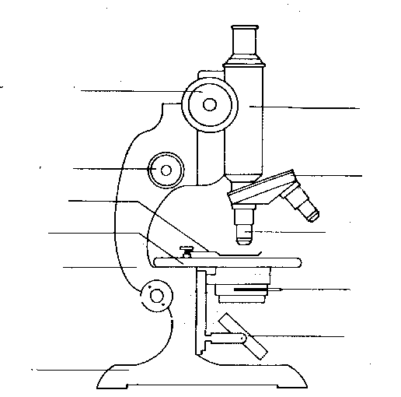
10
11
12
3
4
5
6
9
13
2
1
7
8
1. Ocular lens or eyepiece - most microscopes have a
range of ocular lenses: X5, X10 or X12.5.
2. Body tube or barrel - holds the ocular and objective
lenses at a proper working distance.
3. Coarse adjustment (or coarse focus knob) - moves the body tube up or down to the correct distance for
viewing a specimen in focus.
4. Fine adjustment (or fine focus knob) - controls the
body tube and permits exact focusing.
5. Arm - supports the body tube.
6. Revolving nosepiece - contains the objective lenses
and can be rotated to change the objective lens.
7. Objective lens - changes the magnification of the microscope. A low power objective lens of X10 magnification and a high power objective lens of X40 magnification are often provided. Some microscopes also
have a X5 objective lens.
8. Stage - a platform that holds the slides.
9. Stage clips - hold microscope slides in place.
10. Diaphragm - controls the amount of light reflected through the hole in the stage.
11. Mirror - collects and directs light through the hole in the stage and through the object being viewed.0
12. Base - supports the weight of the microscope.
13. Inclination joint - permits tilting to adjust to eye level.

Setting up the microscope

The following steps should become routine and be followed every time the microscope is set up for use.

1. Place the microscope squarely in front of you with the base positioned a safe distance from the edge of the bench.
2. Place the microscope lamp about 15 cm from the mirror.
3. Using the coarse adjustment, raise the body tube so that the objective lenses do not hit the stage when the
nosepiece is rotated.
4. Using one hand to hold the microscope, turn the revolving nosepiece so that the low power objective (X10) is
pointing downwards towards the stage. You will feel it click into position.
5. Remove the eyepiece lens. Adjust the mirror so that a strong beam of light comes up the barrel.
6. Replace the eyepiece lens and do not move the microscope because this will alter the amount of light entering the
barrel.
7. Place the slide to be examined on the stage so that the specimen is over the hole in the
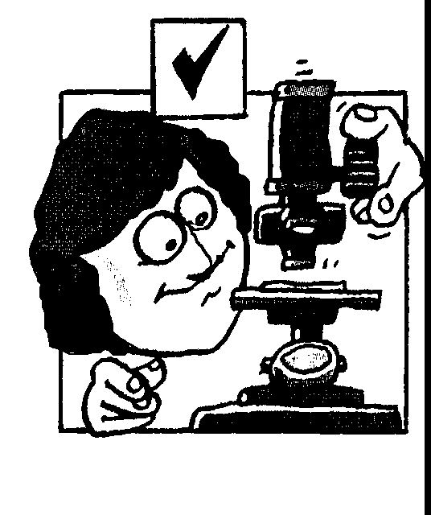
centre.
8. Focus the microscope under Low power by completing the following steps
a) Looking from the side with your eyes level with the microscope stage, wind the body tube down with the coarse adjustment until the low power objective is within
1 cm of the slide.
b) Looking through the ocular lens, slowly turn the coarse adjustment knob so that
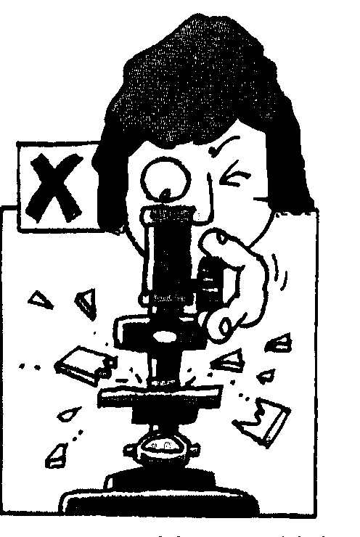
the microscope tube moves upwards until the object is in focus.
c) If you are unable to find the focus, repeat steps a) and b).

NEVER lower the body tube with the coarse adjustment while you are looking into the ocular lens.

10. To focus the microscope under High power, the following steps should now be
undertaken
a) Once you have focussed the object under low power, looking from the side carefully rotate the nosepiece so
that the High Power objective clicks into place. Take care to ensure that the objective misses the slide.
b) Sharpen the focus under High Power with the fine adjustment knob.

NEVER touch the coarse adjustment knob when using the high power objective lens.

Preparation of a Wet Mount Slide

A wet mount of a specimen can be prepared using the following procedure:

1. Clean your microscope slide by wetting it with water and wiping it dry on both sides with a paper towel.
2. Using a pipette, place a drop of water near the centre of the microscope
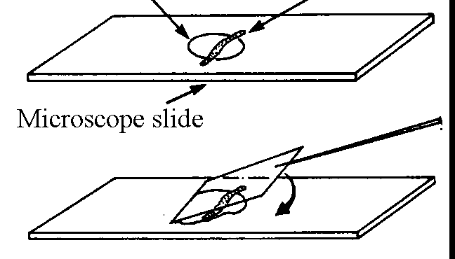
Drop of water Specimen
slide.
3. Place the specimen to be observed in the drop of water using forceps,
dissecting needles or toothpicks.
4. Touch one edge of the coverslip to the water. Allow the water to spread evenly along this edge, then slowly lower the coverslip over the drop. Support the upper edge of the coverslip with a toothpick while lowering it into place as this will prevent the trapping of air bubbles. If air bubbles are trapped they will interfere with your viewing, appearing as circular
objects with thick black outlines.
5. At the end of the lesson remove the coverslip from the slide and dispose of it in the glass bin. Rinse your microscope slide under the tap, wipe dry with a paper towel and return it to the equipment trolley.

Staining
The reasons for staining specimens are to make certain structures more visible or to identify specific chemicals
within the specimen.
Many different stains can be used, such as - methylene blue stains the nucleus and the cell membrane.
- iodine stains starch in granules in a cell.

To prepare a stained wet mount, place a small drop of the stain on the slide with the drop of water.

Magnification of a Microscope

The overall magnification of a microscope can be calculated by multiplying together the magnifications of the ocular lens and objective lens being used.

For example if the ocular magnification = X10
and objective magnification = X40

the overall magnification = 10 x 40 = X400

Measuring with a Microscope

Objects examined under a microscope are usually so small that they cannot be measured with the smallest unit of a ruler i.e. mm or millimetres.
A much smaller unit, the micrometer (μm) is often used.
1μm = 0.000001 m = 0.001mm
or 1000μm = 1mm

An estimate of the size of microscopic objects can be made by comparing them with the size (diameter) of the field of view (the field of view is the circle of light you can see when looking through the microscope).

The field of view for a particular magnification can be determined using the following procedure.
1. Prepare a wet mount of a piece of millimetre graph paper, or use a minigrid slide.
2. Focus this slide using the required magnification.
3. Carefully move the slide so that one grid line touches one side of the field, and another grid line passes through the
diameter of the field of view.
4. Knowing that it is 1 mm between each of the grid lines, estimate the diameter of the field of view.

For example if the following was obtained when the graph paper was seen through the microscope, the diameter of the field of view would be approximately 1.2 mm or 1200 μm
1 mm
0.2 mm

Estimating the Size of an Object under Low Power

To determine the length or width of an object, you need to estimate how many would fit, end to end across the diameter of the field of view at low power.
Then, if the diameter of the low power field of view is known:
the length/width of one object =
For example, the following cell was seen using a microscope with a field of view of 1200 μm:

It was estimated that about three cells will fit, lengthwise, across the field diameter

i.e. the length of one cell =
= = 400 μm (or 0.4 mm)

Biological Diagrams

Drawing plant and animal specimens is one way of accurately recording observations you make in class, at home or in the field.

Biological drawing should show clearly:
1. the external appearance of the whole specimen, or part of the specimen if that is what you have observed
2. any internal features that you see, sometimes revealed by dissecting it eg the internal parts of a flower
3. the positions of structures and how they relate to one another

They should also include:
1. a scale or some other indication of how many times smaller or larger your drawing is compared with the real organism you observed
2. clear labels outside the diagram, with a line connecting each label to the appropriate structure. Avoid crossing lines from different labels. Try not to use arrowheads because these may be used within diagrams for other purposes, such as showing the direction of blood flow etc.

You might sometimes need to annotate a drawing. This allows you to record extra information about the organism that you might not have been able to record in the drawing

General tips for making good biological drawings

1. Use a sharp pencil, a soft rubber and a ruler.
2. Draw a soft outline of your specimen first. You will probably rub these out later.
3. Use a ruler to check proportions, for example, how many times does a leaf’s width measurement fit into its length
and make sure your drawing reflects these proportions as accurately as possible.
4. Use common sense when deciding how large or small to draw your specimen. Just because cells are microscopic does not mean your drawing has to be so small that nobody can see any useful detail. It is better to make a drawing
slightly too large rather than too small.
5. Include a scale line such as
3 mm

or write down the magnification (x10) or reduction (x ¼) of your drawing. This will enable others to work out its
true size.
6. When you are satisfied that you have recorded your specimen’s structure accurately, draw in the final lines with an HB pencil. Do not shade the drawing,

7. If the specimen has an overall detailed pattern on some part eg scales on a snake, you only have to indicate the detail in a small section of your drawing and annotate the diagram to indicate that this is a sample of the all over pattern for a particular part.

8. You should find that you mainly use your ruler for labelling lines and checking size/proportions. There are no living organisms whose structure has perfectly straight lines!
Some additional tips for biological drawing
Do | Avoid
use smooth, continuous lines

if many cells of the same type are visible in the field of view  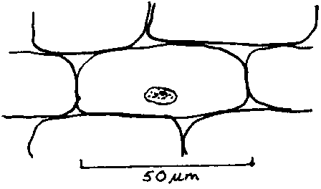 | 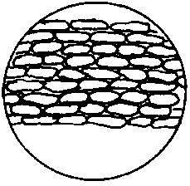
if a structure is missing/lost/damaged  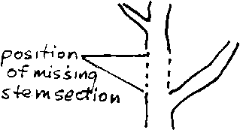 | 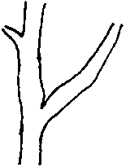
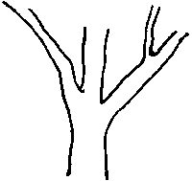 | 

